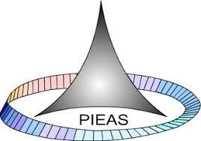

PAKISTAN INSTITUTE OF ENGINEERING AND APPLIED SCIENCES

***Computing Fundamentals & Programming***

**FALL 2020**

Laboratory Exercise-05

Name: Umar Shifaqat

Department: DPAM

Roll No. BS-20-GB-100864

Date: OCT 28, 2020

LAB TASK 01

INPUT

#include<stdio.h>

int main()

{

int number,sum,no,value;

sum=0;

no=0;

printf("This prgram adds the ODD numbers\(ONLY\). \n\n\t\t Please Enter the Integers one by one\n");

for(value=1;value<=10;value++)

{ printf("\t\tInteger = ");

scanf("%d",&number);

if(number%2==1)

{ sum+=number;

no+=1; }

else

{ sum=sum;

no+=0; }

}

printf("\n\tSum of ODD Numbers is %d.\n\tNumber of Odd No's entered is %d.",sum,no);

getchar();

getchar();

getchar();

return 0;

}

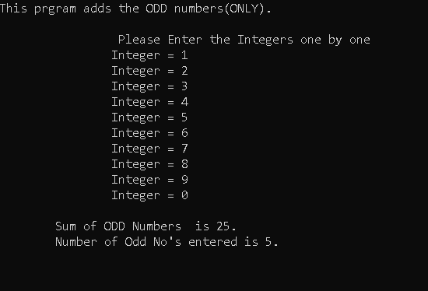

LAB TASK 02

INPUT

#include<stdio.h>

int main()

{

int number;

number=1;

printf("All Natural Numbers from 1 to 10 are : \n\n");

do

{ printf(" %d",number);

number++;

}

while(number<=10);

getchar();

getchar();

return 0;

}

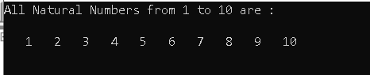

LAB TASK 03

INPUT

#include<stdio.h>

int main ()

{

int number,factorial,x;

factorial=1;

printf("\n\t This Program Calculate the Factorial of a Number\n");

printf("\n\n\t\t\tEnter the number : ");

scanf("%d",&number);

for(x=1;x<=number;x++)

factorial*=x;

printf("\n\tThe Factorial is %d.",factorial);

getchar();

getchar();

return 0;

}

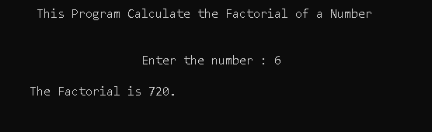

LAB TASK 04

INPUT

#include<stdio.h>

int main ()

{

int start,end,prime,i,n,total=0;

printf("Enter the Number for Start of Range: ");

scanf("%d",&start );

printf("Enter the Number for End of Range: ");

scanf("%d",&end );

for (n=start;n<=end;n++)

{

if(n==1)

prime=0;

else

{ prime=1;

for(i=2;i<n;i++)

{

if (n%i==0)

{ prime=0; break;}

}}

if(prime==1)

{ printf(" %d ",n); total++;}

}

printf("\n\n\tThe total Number of prime numbers is %d.",total);

getchar();

getchar();

getchar();

return 0;

}

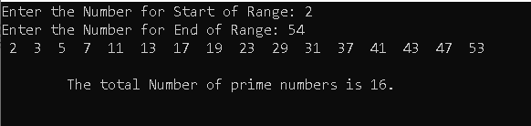

LAB TASK 05

INPUT

#include<stdio.h>

int main ()

{

int number,square,x;

printf("\n\t\tEnter the Number : ");

scanf("%d",&number);

for(x=1;x<=number;x++)

{ square=x*x;

printf("\n\n\t\t>> The Square of %d = %d",x,square);

}

getchar();

getchar();

getchar();

return 0;

}

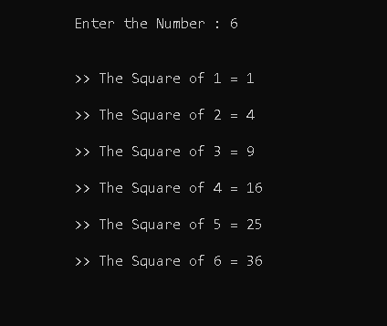

LAB TASK 06

INPUT

#include<stdio.h>

int main()

{

int num,i=0;

printf("\n\tThis program checks whether a number is IDD or EVEN.\n\n");

while(i<5)

{ printf("\n\n\t\tEnter a Number : ");

scanf("%d",&num);

if (num%2==0)

printf("\t\tStatus : EVEN");

else if (num%2==1)

printf("\t\tStatus : ODD");

i++;

}

getchar();

getchar();

getchar();

return 0;

}

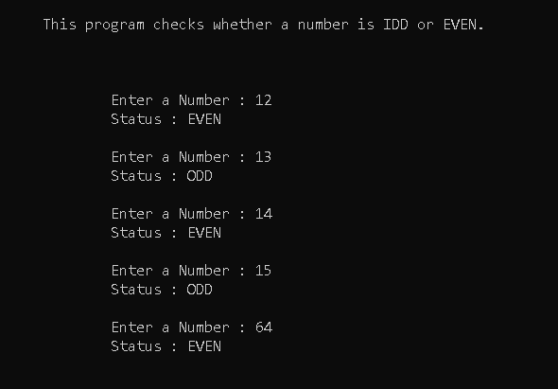

LAB TASK 07

INPUT

#include<stdio.h>

int main()

{

int num,i=0,even=0,odd=0;

printf("\n\tThis program checks whether a number is IDD or EVEN.\n\n");

while(i<5)

{ printf("\n\n\t\tEnter a Number : ");

scanf("%d",&num);

if (num%2==0)

{ printf("\t\tStatus : EVEN");

even++; }

else if (num%2==1)

{ printf("\t\tStatus : ODD");

odd++; }

i++;

}

printf("\n\n\t\tODD NUMBERS: %d\n\t\tEVEN NUMBERS : %d",odd,even);

getchar();

getchar();

getchar();

return 0;

}

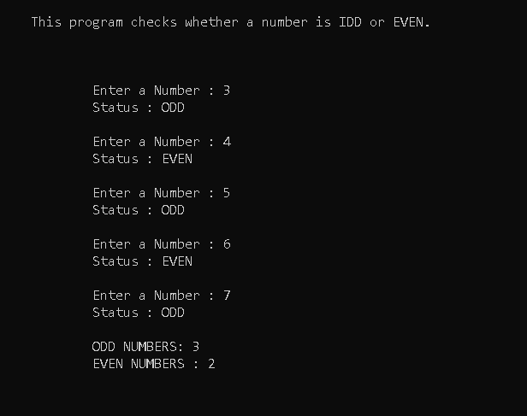

LAB TASK 08

INPUT

#include<stdio.h>

int main()

{

int A,n,ans=1;

printf("\n\t\t\tIn this program, you can check any number raised to some power.\n\n");

printf("\n\t\t Please Enter the Number : ");

scanf("%d",&A);

printf("\n\t\tPlease Enter the Power : ");

scanf("%d",&n);

int i=1;

while(i<=n)

{

ans=ans*A;

i++;

}

printf("\n\t\tThe %dth power of %d is %d",n,A,ans);

getchar();

getchar();

return 0;

}

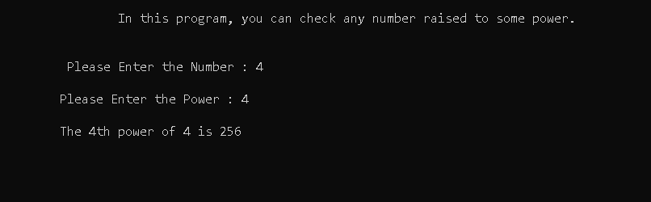

LAB TASK 09

INPUT

#include<stdio.h>

int main()

{

int num,i=1,ans=0;

do

{

ans+=2;

printf("\n\t\t2 * %d = %d ",i,ans);

i++;

} while(i<=10);

getchar();

getchar();

return 0;

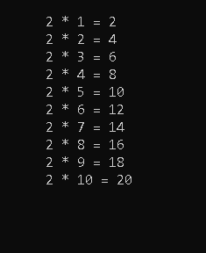

LAB TASK 10

INPUT

#include<stdio.h>

int main()

{

int num1,num2,i,j,product=0;

printf("\n\tEnter the numbers to multiply");

printf("\n\n\t\tEnter 1st number: ");

scanf("%d",&num1 );

printf("\n\t\tEnter 2nd number: ");

scanf("%d",&num2 );

i=1;

do

{

j=1;

while(j<=num2)

{

product+=1;

j++;

}

i++;

} while(i<=num1);

printf("The product is %d ",product);

getchar();

getchar();

getchar();

getchar();

return 0;

}

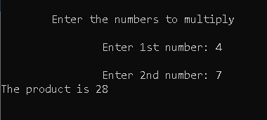

**HOME TASKS**

HOME TASK 01

INPUT

#include<stdio.h>

int main ()

{

int prime,i,j,n,total=0;

printf("Enter the Number n: ");

scanf("%d",&n );

for (j=1;j<=n;j++)

{

if(j==1)

prime==0;

else

{ prime=1;

for(i=2;i<j;i++)

{

if (j%i==0)

{ prime=0; break;}

}}

if(prime==1)

{ printf(" %d ",j);

total+=j;}

}

printf("\n\n\tThe Sum of Prime numbers upto %d is %d.",n,total);

getchar();

getchar();

getchar();

return 0;

}

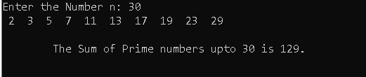

HOME TASK 02

INPUT

#include<stdio.h>

int main()

{

int m,n;

printf("Enter a value for n: ");

scanf("%d",&n);

printf("Enter a value for m (m should be less than n): ");

scanf("%d",&m);

while(n>0)

{

printf("\n M=%d , N=%d, N/M=%d",m,n,n/m);

n=n/m;

}

getchar();

getchar();

getchar();

return 0;

}

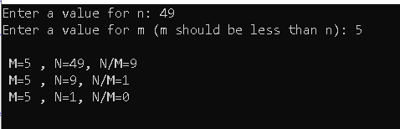

HOME TASK 03

(a)

INPUT

#include<stdio.h>

int main()

{

int a,n,i=1;

printf("Enter a vale of a:");

scanf("%d",&a );

printf("Enter a vale of n:");

scanf("%d",&n );

while(i<=n)

{

printf(" %d,",a);

a=a*2+1;

i++;

}

printf("\b ");

getchar();

getchar();

getchar();

return 0;

}

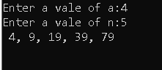

(b)

INPUT

#include<stdio.h>

int main()

{

int a,N,n=1,i=1;

printf("Enter a vale of a:");

scanf("%d",&a );

printf("Enter a vale of N:");

scanf("%d",&N );

do

{

printf("Term no.%d is %d\n",n,a);

a=a*2+1;

i=i*2+1;

n++;

}while(i<=N);

printf("\b ");

getchar();

getchar();

getchar();

return 0;

}

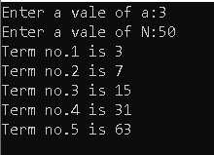

HOME TASK 04

INPUT

#include<stdio.h>

int main()

{

int A,n,ans=1;

printf("\n\t\t\tIn this program, you can check any number raised to some power.\n\n");

printf("\n\t\t Please Enter the Number : ");

scanf("%d",&A);

printf("\n\t\tPlease Enter the Power : ");

scanf("%d",&n);

int i=1;

while(i<=n)

{

ans=ans*A;

i++;

}

printf("\n\t\tThe %dth power of %d is %d",n,A,ans);

getchar();

getchar();

return 0;

}

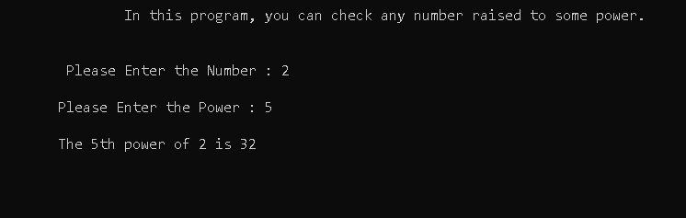

HOME TASK 05

INPUT

#include<stdio.h>

int main()

{

int num1,num2,lcm,i,n;

printf("\n\tEnter the numbers to find LCM.\n\t\t number 1: ");

scanf("%d",&num1);

printf("\n\t\tEnter number 2: ");

scanf("%d",&num2);

if(num1>num2)

n=num1;

else

n=num2;

for(i=n;i>=n;i++)

{

if(i%num1==0 && i%num2==0)

{ lcm=i;

break;

}

}

printf("\n\n\t\t\tThe LCM of %d and %d is %d",num1,num2,lcm);

getchar();

getchar();

return 0;

}

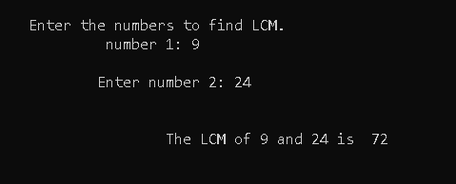

HOME TASK 06

INPUT

#include<stdio.h>

int main()

{

int number,n=0;

printf("Enter the number : ");

scanf("%d",&number);

while(number!=0)

{

n=(n*10)+(number%10);

number/=10;

}

while(n!=0)

{

switch(n%10)

{

case 0:

printf("Zero ");

break;

case 1:

printf("One ");

break;

case 2:

printf("Two ");

break;

case 3:

printf("Three ");

break;

case 4:

printf("Four ");

break;

case 5:

printf("Five ");

break;

case 6:

printf("Six ");

break;

case 7:

printf("Eight ");

break;

case 8:

printf("Seven ");

break;

case 9:

printf("Nine ");

break;

}

n=n/10;

}

getchar();

getchar();

return 0;

}

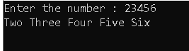

HOME TASK 07

INPUT

#include<stdio.h>

int main ()

{

int number,dig1,dig2,dig3,quotient,n,x,f1,f2,f3;

printf("Enter the upper limit : ");

scanf("%d",&n);

printf("Strong Numbers between 1 and %d :",n);

for(number=1;number<=n;number++)

{

dig1=number%10;

quotient=number/10;

dig2=quotient%10;

dig3=quotient/10;

f1=1;f2=1;f3=1;

for(x=1;x<=dig1;x++)

f1*=x;

for(x=1;x<=dig2;x++)

f2*=x;

for(x=1;x<=dig3;x++)

f3*=x;

if(f1+f2+f3==number)

printf("1,2 %d, ",number);

}

getchar();

getchar();

getchar();

return 0;

}

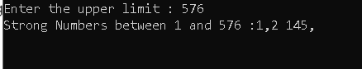

HOME TASK 08

INPUT

#include<stdio.h>

int main()

{

int number,table,i;

printf("\n\tEnter the Number to print Table : ");

scanf("%d",&number);

printf("\t\tMultiplication Table of %d :\n",number);

for(i=1;i<=10;i++)

{

table=i*number;

printf("\n\t\t%d*%d=%d",number,i,table);

}

getchar();

getchar();

return 0;

}

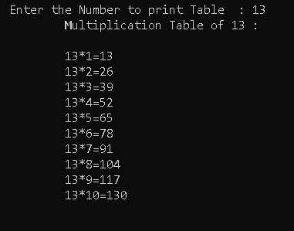

HOME TASK 09

INPUT

#include<stdio.h>

int main()

{

int number,dig1,dig2,dig3,dig4,dig5,quotient;

printf("Enter the number : ");

scanf("%d",&number);

dig1=number%10;

quotient=number/10;

dig2=quotient%10;

quotient/=10;

dig3=quotient%10;

quotient/=10;

dig4=quotient%10;

dig5=quotient/10;

printf("\nFirst Digit = %d \n Last Digit = %d ",dig5,dig1);

getchar();

getchar();

return 0;

}

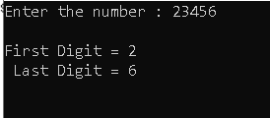

HOME TASK 10

INPUT

#include<stdio.h>

int main()

{

int number,swap,dig1,dig2,dig3,dig4,dig5,quotient;

printf("Enter the number : ");

scanf("%d",&number);

dig1=number%10;

quotient=number/10;

dig2=quotient%10;

quotient/=10;

dig3=quotient%10;

quotient/=10;

dig4=quotient%10;

dig5=quotient/10;

swap=10000*dig1+1000*dig4+100*dig3+10*dig2+dig5;

printf("\nNumber after swappingfirst and last digits is : %d ",swap);

getchar();

getchar();

return 0;

}

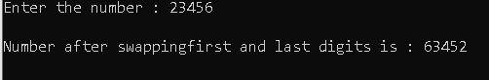

HOME TASK 11

INPUT

#include<stdio.h>

int main()

{

int number,reverse,dig1,dig2,dig3,dig4,dig5,quotient;

printf("Enter the number : ");

scanf("%d",&number);

dig1=number%10;

quotient=number/10;

dig2=quotient%10;

quotient/=10;

dig3=quotient%10;

quotient/=10;

dig4=quotient%10;

dig5=quotient/10;

reverse=10000*dig1+1000*dig2+100*dig3+10*dig4+dig5;

if(reverse==number)

printf("\n%d is palindrome ",number);

else

printf("\n%d is not palindrome ",number);

getchar();

getchar();

return 0;

}

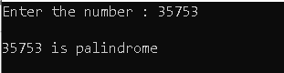

HOME TASK 12

INPUT

#include<stdio.h>

int main()

{

int number,product,dig1,dig2,dig3,dig4,dig5,quotient;

printf("Enter the number : ");

scanf("%d",&number);

dig1=number%10;

quotient=number/10;

dig2=quotient%10;

quotient/=10;

dig3=quotient%10;

quotient/=10;

dig4=quotient%10;

dig5=quotient/10;

product=dig1*dig2*dig3*dig4*dig5;

printf("\nThe Product of the digits is %d ",product);

getchar();

getchar();

return 0;

}

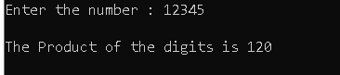

HOME TASK 13

INPUT

#include<stdio.h>

int main()

{

int num,i;

printf("\n\tEnter the number: ");

scanf("%d",&num);

for(i=1;i<=num;i++)

{

if(num%i==0)

printf("%d, ",i);

}

getchar();

getchar();

return 0;

}

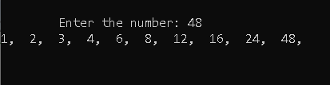

HOME TASK 14

INPUT

#include<stdio.h>

#include<math.h>

int main()

{

int n=1,sum=0;

float sq;

while(n<=25)

{

sq=sqrt(n);

printf("\nSquare root of %d is %f",n,sq);

n++;

}

getchar();

getchar();

getchar();

return 0;

}

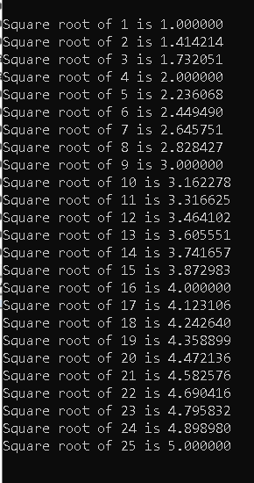

HOME TASK 15

INPUT

#include<stdio.h>

int main()

{

int n,i,sq,sum=0;

printf("Enter the value of n: ");

scanf("%d",&n);

for(i=1;i<=n;i++)

{

sq=i*i;

printf("\n\t%d*%d=%d",i,i,sq);

sum+=sq;

}

printf("\n\tSum = %d",sum);

getchar();

getchar();

getchar();

return 0;

}

